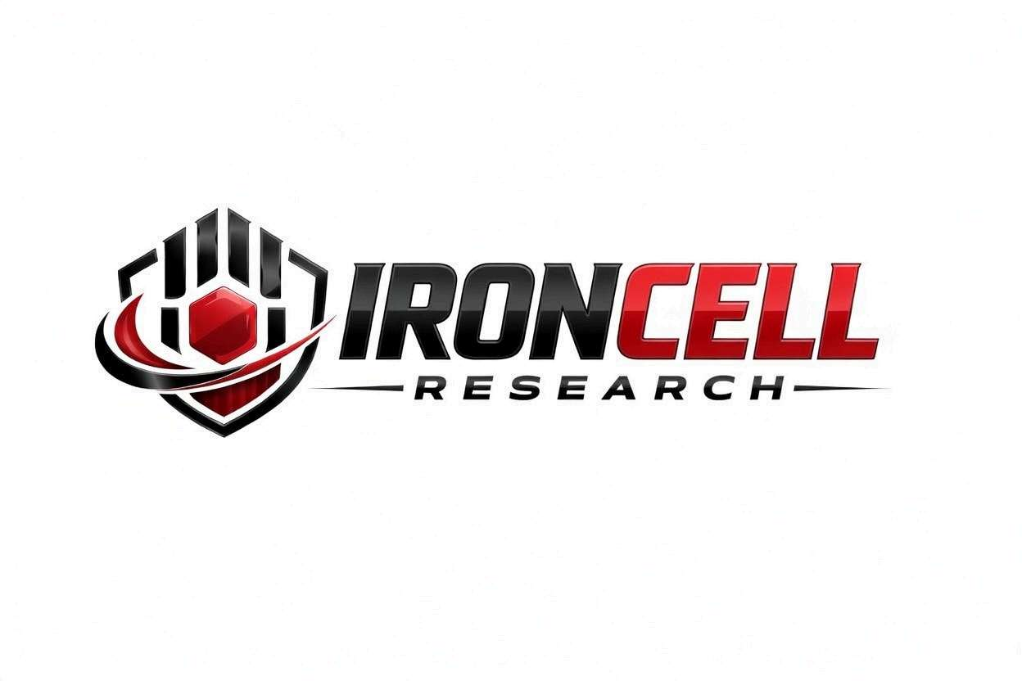
PEPTIDE RESEARCH BRIEF
GHK-Cu
Copper Peptide Complex | Tissue Remodeling & Regeneration

Description, Benefits, Dosage & Research Overview

Iron Cell Research
IronCellResearch.com
For Research Use Only


Compound Overview
Compound Name | GHK-Cu (Glycyl-L-Histidyl-L-Lysine Copper)
Classification | Tripeptide-Copper Complex
Molecular Formula | C14H24N6O4Cu
Molecular Weight | 403.93 g/mol
CAS Number | 49557-75-7
Biological Half-Life | Approximately 30-60 minutes
Purity | Greater than or equal to 99%
Storage | Lyophilized, -20C, protected from light
Research Status | Extensive preclinical research

Description
GHK-Cu is a naturally occurring tripeptide with a high affinity for copper(II) ions. Found in human plasma, saliva, and urine, it was first identified by Dr. Loren Pickart in 1973. Plasma levels of GHK-Cu decline significantly with age, from approximately 200 ng/mL at age 20 to roughly 80 ng/mL by age 60.
GHK-Cu activates a broad range of tissue remodeling, anti-inflammatory, antioxidant, and reparative processes. Research has shown that this peptide modulates the expression of over 4,000 human genes, effectively resetting gene expression patterns toward a healthier, more regenerative state.

Mechanism of Action

Tissue Remodeling & ECM Regulation
GHK-Cu stimulates synthesis of collagen types I and III, as well as elastin. It activates matrix metalloproteinases (MMPs) and their tissue inhibitors (TIMPs) to promote balanced extracellular matrix turnover, and promotes glycosaminoglycan and proteoglycan production for improved tissue structure.

Anti-Inflammatory Signaling
GHK-Cu suppresses pro-inflammatory cytokines including TNF-alpha, IL-6, IL-1beta, and TGF-beta. It modulates the NF-kB pathway and reduces oxidative damage through upregulation of superoxide dismutase (SOD) and other antioxidant enzymes.

Wound Healing & Tissue Repair
GHK-Cu accelerates wound closure and re-epithelialization. It promotes angiogenesis through upregulation of VEGF and FGF-2, attracts immune cells and fibroblasts to wound sites, and reduces scarring by promoting organized collagen deposition.

Stem Cell & Gene Expression
GHK-Cu upregulates genes associated with tissue repair while downregulating inflammatory gene expression. It promotes mesenchymal stem cell differentiation and effectively resets cellular gene expression toward a regenerative profile.

Research Benefits

Skin Rejuvenation
- Collagen Stimulation: Increases collagen and elastin production, improving skin firmness and elasticity.
- Anti-Aging: Reduces fine lines and wrinkles, improves skin thickness, and reverses photoaging damage.
- Skin Quality: Enhances skin clarity, reduces hyperpigmentation, and improves overall skin texture.

Wound Healing
- Accelerated Closure: Significantly speeds wound healing in preclinical models.
- Reduced Scarring: Promotes organized tissue repair, minimizing hypertrophic scarring.
- Chronic Wounds: Shows benefit in diabetic ulcer and chronic wound models.

Hair Growth
- Follicle Stimulation: Promotes hair follicle growth and extends the anagen (growth) phase.
- Scalp Health: Improves scalp condition and follicle microenvironment.

Anti-Inflammatory & Antioxidant
- Systemic Effects: Reduces systemic inflammation markers in preclinical models.
- Organ Protection: Demonstrates protective effects in gut mucosa and lung tissue models.

Bone & Joint Health
- Osteoblast Stimulation: Promotes bone cell differentiation and bone formation.
- Cartilage Preservation: Supports cartilage integrity and joint health.

Dosage & Administration
The following dosage information is provided for research reference purposes only.
Protocol | Dose Range | Route | Frequency
Low / Introductory | 1-2 mg | SubQ Injection | Daily
Standard Protocol | 2-5 mg | SubQ Injection | Daily
Topical Application | 1-3% concentration | Topical | 2x daily
Maintenance | 1-2 mg | SubQ Injection | 3x per week

Reconstitution Guidelines
Solvent | Sterile bacteriostatic water
Reconstitution Volume | 1 mL per vial
Mixing | Gently swirl until dissolved, do not shake
Storage After Reconstitution | Refrigerate at 2-8C, use within 21 days
Injection Site | Subcutaneous (abdomen, thigh), rotate sites

Safety Profile
GHK-Cu has an excellent safety profile consistent with its role as an endogenous human peptide:
- General Tolerability: As a naturally occurring compound, GHK-Cu demonstrates excellent tolerability with minimal adverse effects in preclinical studies.
- Injection Site Reactions: Mild, transient redness or discomfort may occur at injection sites.
- Drug Interactions: No significant drug interactions have been identified in research to date.
- Pregnancy & Nursing: Insufficient safety data for use during pregnancy or lactation.

Key References
- Pickart L, Vasquez-Soltero JM, Margolina A. GHK Peptide as a Natural Modulator of Multiple Cellular Pathways in Skin Regeneration. BioMed Research International. 2015.
- Pickart L, Margolina A. Regenerative and Protective Actions of the GHK-Cu Peptide in the Light of the New Gene Data. International Journal of Molecular Sciences. 2018.
- Pickart L. The Human Tripeptide GHK-Cu in Prevention of Oxidative Stress and Degenerative Conditions of Aging. Oxidative Medicine and Cellular Longevity. 2012.
- Maquart FX, et al. In Vivo Stimulation of Connective Tissue Accumulation by the Tripeptide-Copper Complex GHK-Cu. FEBS Letters. 1999.
- Canapp SO, et al. The Effect of Topical Tripeptide-Copper Complex on Healing of Ischemic Open Wounds. Veterinary Surgery. 2003.
- Arul V, et al. Biotinylated GHK Peptide Promotes Wound Healing in Streptozotocin-Induced Diabetic Rats. Journal of Surgical Research. 2005.
- Kang YA, et al. Copper-GHK Increases Expression of Integrin in Human Dermal Fibroblasts. Journal of Investigative Dermatology. 2009.

Contact & Information
Company | Iron Cell Research
Website | IronCellResearch.com
Email | orders@ironcellresearch.com
Product Support | Available via website contact form

Disclaimer
This document is intended for informational and research purposes only. GHK-Cu is sold as a research compound and is not intended for human consumption. The information provided herein does not constitute medical advice, diagnosis, or treatment recommendations. All research applications should comply with applicable institutional, local, and federal regulations. Iron Cell Research makes no claims regarding the therapeutic efficacy of GHK-Cu for any medical condition. Researchers should consult with qualified healthcare professionals and institutional review boards before initiating any research protocols involving human subjects.
Iron Cell Research - For Research Use Only


